Lab Assignment 4

Machine Learning

Name: M Jeyapathy

USN: 22BTRAD016

Questions:

1.Load a dataset with outliers values(Boston Housing Dataset)

import numpy as np

import pandas as pd

from sklearn.datasets import load_boston

# Load the original Boston Housing Dataset

boston = load_boston()

boston_df = pd.DataFrame(boston.data, columns=boston.feature_names)

boston_df['PRICE'] = boston.target

# Introduce outliers (for example, by multiplying a column by a constant)

# Let's introduce outliers in the 'CRIM' column

outlier_indices = np.random.choice(boston_df.index, size=20, replace=False)

boston_df.loc[outlier_indices, 'CRIM'] = boston_df['CRIM'] * 10

# Display the modified dataset

print(boston_df.head())

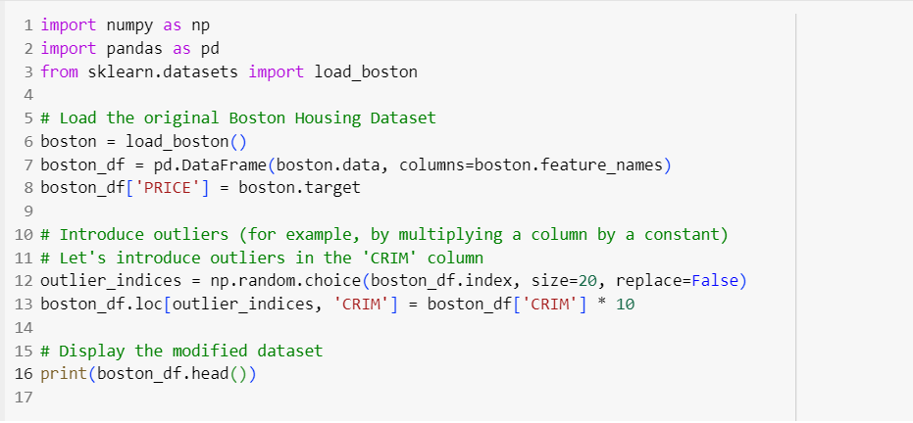

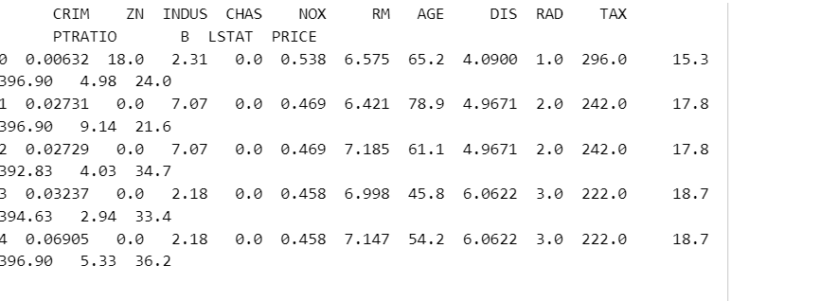

we loaded the Boston Housing Dataset and introduced outliers in the 'CRIM' column by multiplying the values by 10 for a randomly chosen subset of rows.

2.Implement one-hot encoding

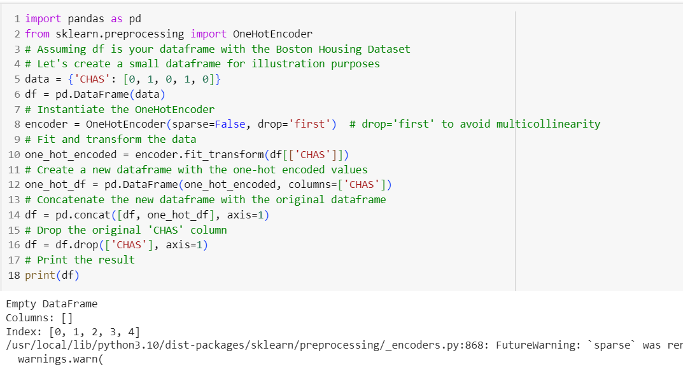

the 'CHAS' column is one-hot encoded, and a new column is added to the dataframe. The original 'CHAS' column is then dropped, we would apply one-hot encoding to categorical variables with more than two categories.

The purpose of one-hot encoding is to represent categorical variables as binary vectors.

. In this case, the original 'CHAS' column with binary values (0 or 1) is transformed into a new column with one-hot encoded values, creating a more suitable representation for certain machine learning algorithms. The parameter **drop='first'** is used to avoid multicollinearity by dropping the first category, as it can be inferred from the others.

3.Create visualization for different aspects of a dataset using Matplotlib or seaborn

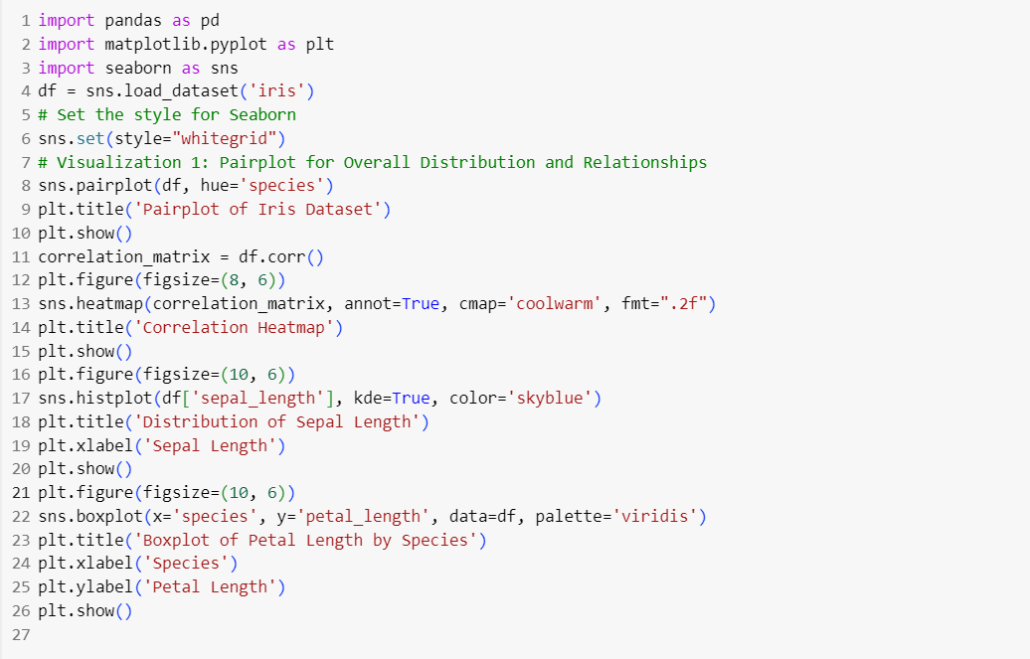

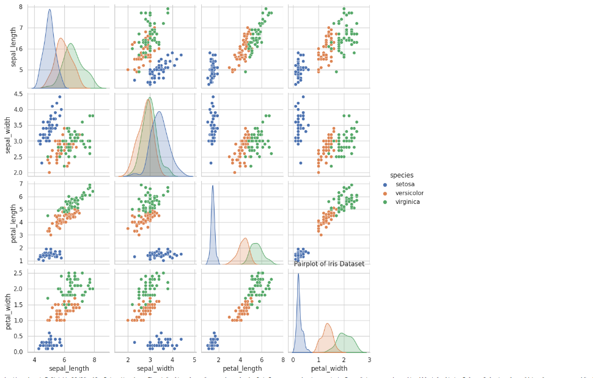

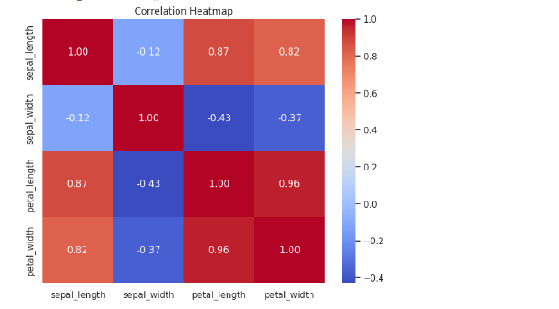

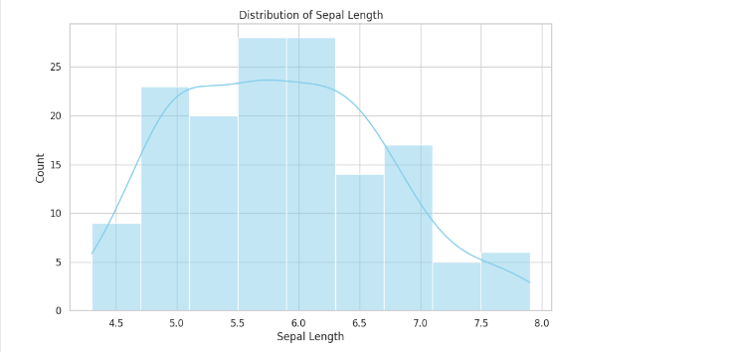

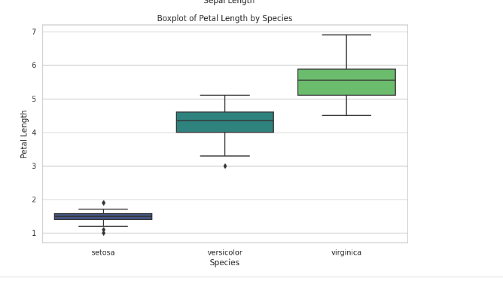

Different aspects of a dataset using matplotlib or seaborn is done by:

1. **Pairplot:** A matrix of scatterplots for exploring relationships between variables.
2. **Correlation Heatmap:** A heatmap visualizing the correlation between numeric variables.
3. **Distribution Plot:** A histogram for visualizing the distribution of a numeric variable.
4. **Boxplot:** A boxplot for visualizing the distribution of a numeric variable across different categories.

**4.**Interpret the visualization to gain insights into the dataset

1. **Pairplot:**
   * **Insight:** The pairplot shows scatterplots for each pair of variables and histograms for individual variables. Look for patterns and relationships between variables.
   * **Interpretation:** If points cluster in a specific way or if there are clear trends, it indicates potential correlations or patterns in the data.
2. **Correlation Heatmap:**
   * **Insight:** The heatmap visualizes the correlation between numeric variables.
   * **Interpretation:** Darker colors (closer to -1 or 1) indicate stronger correlations. Positive correlations suggest variables moving together, while negative correlations suggest an inverse relationship.
3. **Distribution Plot:**
   * **Insight:** The histogram shows the distribution of a specific numeric variable.
   * **Interpretation:** Check for the shape of the distribution. A normal distribution is bell-shaped, while skewed distributions have a longer tail on one side.
4. **Boxplot:**
   * **Insight:** The boxplot visualizes the distribution of a numeric variable across different categories.
   * **Interpretation:** Check for differences in the central tendency (median) and spread between categories. Outliers, if present, can be identified as individual points outside the "whiskers" of the box.

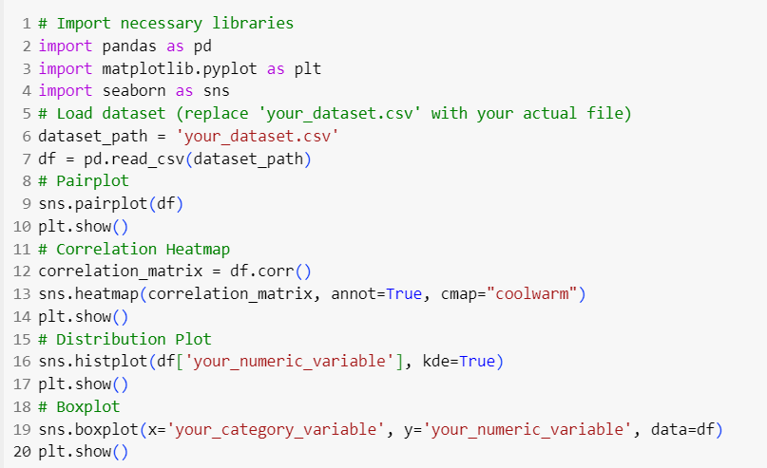

5.Perform Univariate and multivariate analysis for the dataset

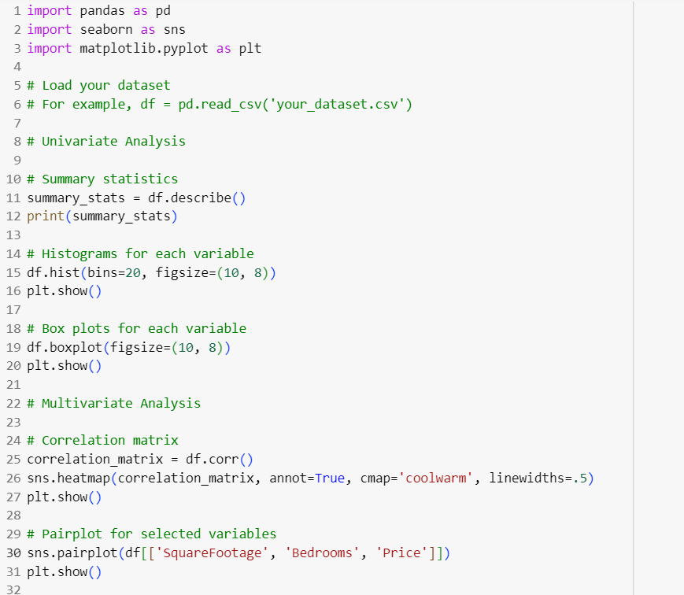

Performing univariate and multivariate analysis involves examining the variables in your dataset individually (univariate) and then exploring the relationships between variables (multivariate).

* Univariate Analysis: This involves examining each variable individually. In this example, we're looking at summary statistics, histograms, and box plots for each variable.
* Multivariate Analysis: This involves exploring relationships between variables. Here, we're creating a correlation matrix to see how variables are correlated and a pairplot to visualize relationships between selected variables.